Name: 7th Grade Date:

Criterion C Assessment: Communicating

Level | General descriptor – The student is able to … | In this report…
1-2 | use limited mathematical language, limited forms of mathematical representation to present information, and communicate through lines of reasoning that are difficult to understand. | there is poor use of mathematical symbols, information is displayed in a disorganized manner, and / or your explanation is difficult to follow.  The debatable question is addressed with no much detail.
3-4 | use some appropriate mathematical language, use different forms of mathematical representation to present information adequately, communicate through lines of reasoning that are able to be understood, although these are not always coherent, and adequately organize information using a logical structure. | there is use of mathematical symbols but not consistently, information is displayed with a graphic organizer and structured in logical way, and / or your explanation can be followed but not always coherent.  The debatable question is addressed with some detail.
5-6 | usually use appropriate mathematical language, usually use different forms of mathematical representation to present information correctly, communicate through lines of reasoning that are usually coherent, and present work that is usually organized using a logical structure. | mathematical symbols are consistently used, information is displayed with two or more graphic organizers, and/or your explanation can be easily read, it is coherent and follows a mostly logical structure. The debatable question is addressed in detail.
7-8 | consistently use appropriate mathematical language, consistently use different forms of mathematical representation to present information correctly, communicate clearly through coherent lines of reasoning, and present work that is consistently organized using a logical structure. | mathematical symbols are consistently used without mistakes, information is displayed with two or more graphic organizers with proper labeling, titles and units, and / or your explanation is clear, concise and clean, coherent and follows a logical structure. The debatable question is fully addressed.

The unit
Inquiry Statement: Establishing equivalences in a logical way helps us to develop a healthy life.

Key Concept: Logic Related Concepts: Equivalence, representation, simplification.

The task
In this task you need to
a) create a list of types and amount of food a typical teenager could eat in a day to have enough calcium, and b) explain connections between what we have studied in this unit and the unit debatable question.
You will create a short report answering a) and b) in detail. In the report, you will explain and show your calculations.

The criterion
Your work will be assessed according to how well you communicate in math based on the rubric above.

Do not forget to include:
- Explanation of how do you decide the number of decimal places to keep.
- Units. Express your answer in everyday units (cups, slices, spoons, etc.)
- Equal signs wherever necessary.
- Organized calculations with all steps.
- Complete sentences.
Resources:

- List of calcium content in food (provided)
- Chart of recommended calcium intake (provided)

- Your notebook
- Dictionary
- Paper, pencil and eraser

Part A: Health Brochure
You are a nurse working at this school.
Create a nutritional brochure for the MYP students. Include an example of a list of foods that a typical MYP student could eat in a day to consume enough calcium. List the foods, the amounts to eat and how much calcium in mg each food contains.
Example: 2 slices of bread contain 60 mg of calcium.
Design and use a chart or any other graphic tool to organize your work.
Show how you calculate the total amount of calcium ingested in a day, and compare this amount with the recommended dietary allowance for calcium.

Part B: Unit reflection
Explain the connections between what you have studied in this unit and the unit debatable question: How do we use logic to make decisions about our health?

Describe at least two examples from the work we have done in class.
Explain the connections in detail using proper math notation in the examples.

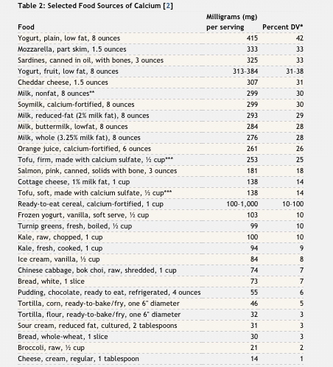

Table 1: Recommended Dietary Allowances (RDAs) for Calcium [1]
Age | Male | Female | Pregnant | Lactating
0–6 months* | 200 mg | 200 mg
7–12 months* | 260 mg | 260 mg
1–3 years | 700 mg | 700 mg
4–8 years | 1,000 mg | 1,000 mg
9–13 years | 1,300 mg | 1,300 mg
14–18 years | 1,300 mg | 1,300 mg | 1,300 mg | 1,300 mg
19–50 years | 1,000 mg | 1,000 mg | 1,000 mg | 1,000 mg
51–70 years | 1,000 mg | 1,200 mg
71+ years | 1,200 mg | 1,200 mg

